AWS VPC
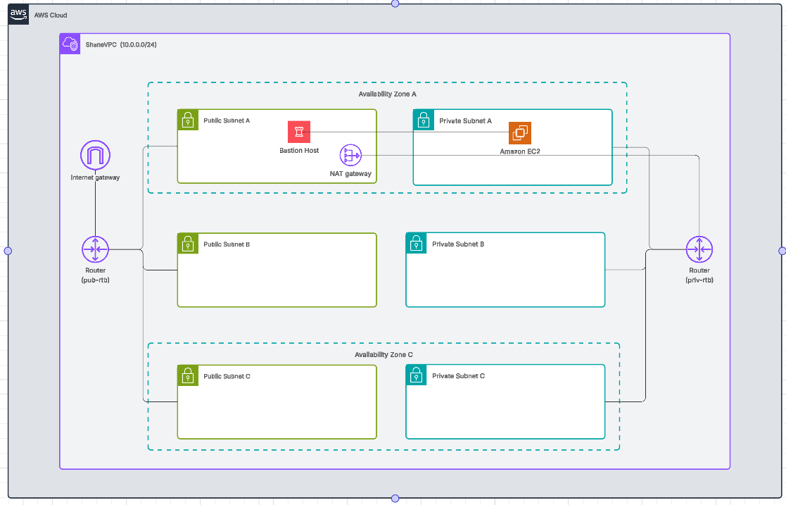

VPC Creation

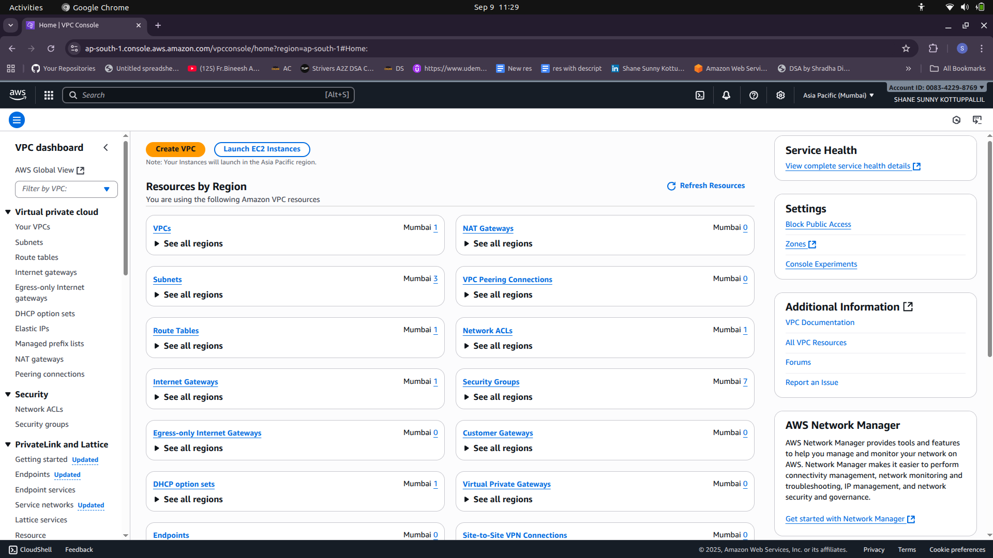
VPC CIDR : 10.0.0.0/24

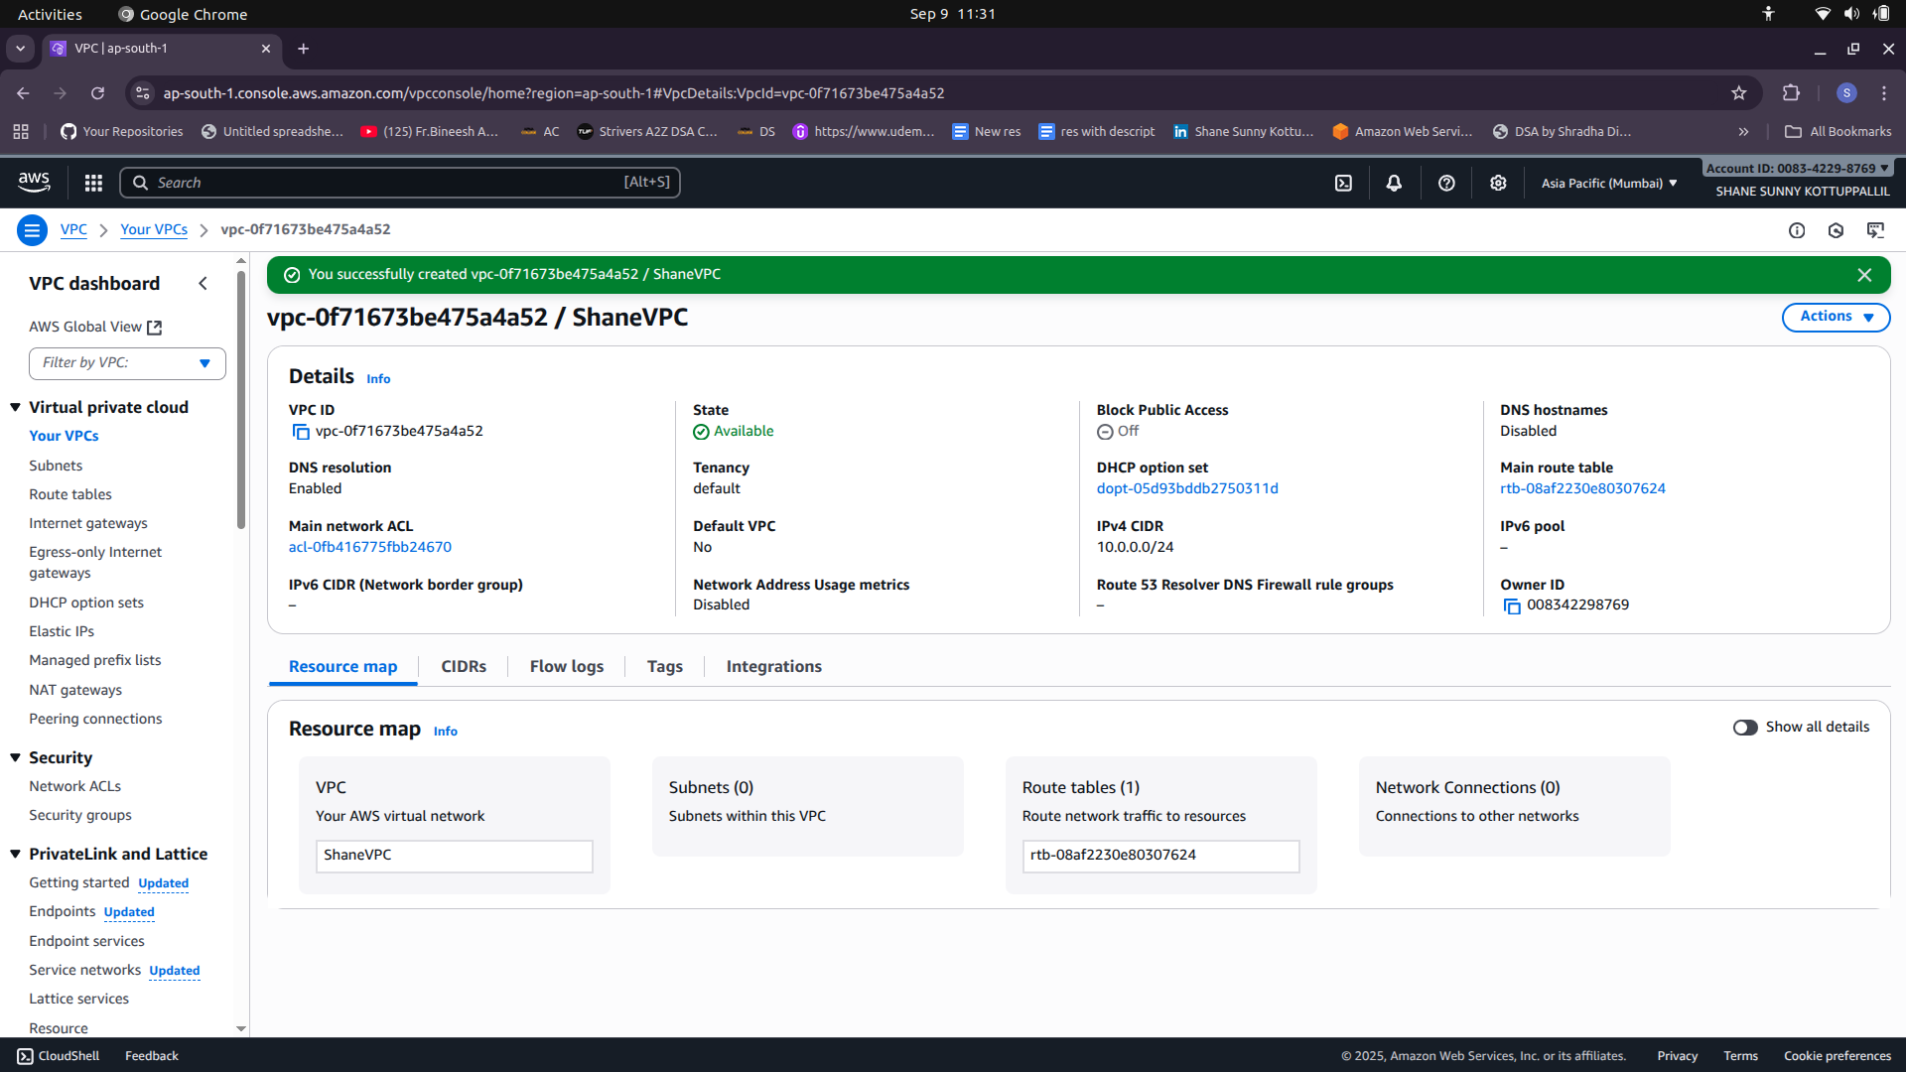

Subnetting
Subnets on 3 Different Azs

1) Availability Zone A
Private Subnet A (25 hosts)
Public Subnet A (55 hosts)

2) Availability Zone B
Private Subnet B (55 hosts)
Public Subnet B (25 hosts)

3) Availability Zone C
Private Subnet C (25 hosts)
Public Subnet C (25 hosts)

Subnetting VLSM (Variable Length Subnet Masking)

VPC CIDR 10.0.0.0/24
Subnet Mask 255.255.255.0
Maximum Number of Hosts = 256

Public A (55 Hosts)
Host bits =6
/26
SM = 255.255.255.192
BS = 256-192 =64
10.0.0.0/26 – 10.0.0.63/26

Private B (55 Hosts)
10.0.0.64/26 – 10.0.0.127/26

Private A (25 Hosts)
Host bits = 5
/27
SM = 255.255.255.224
BS = 32
10.0.0.128/27 – 10.0.0.159/27

Public B (25 Hosts)
10.0.0.160/27 – 10.0.0.191/27

Private C (25 Hosts)
10.0.0.192/27 – 10.0.0.223/27

Public C (25 Hosts)
10.0.0.224/27 – 10.0.0.255/27

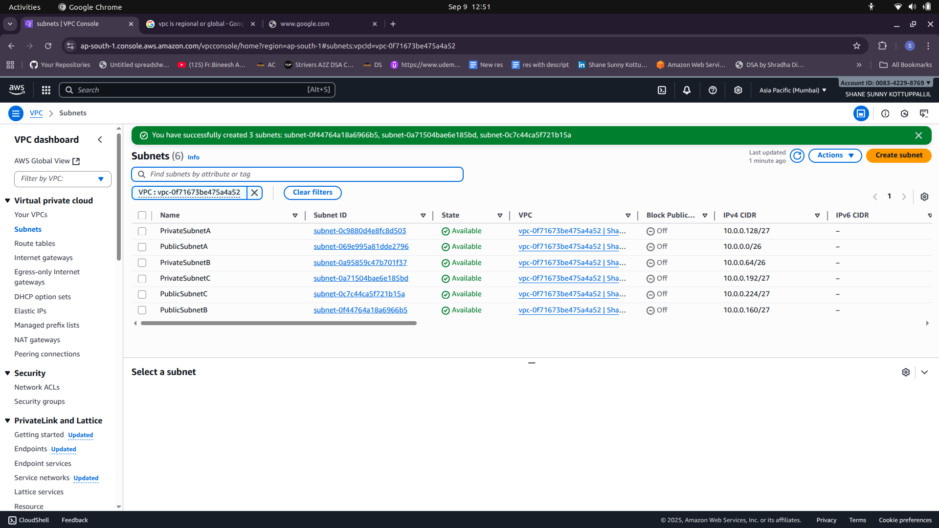

Internet Gateway (IGW)
- one per vpc is allowed

ShaneVPC-igw

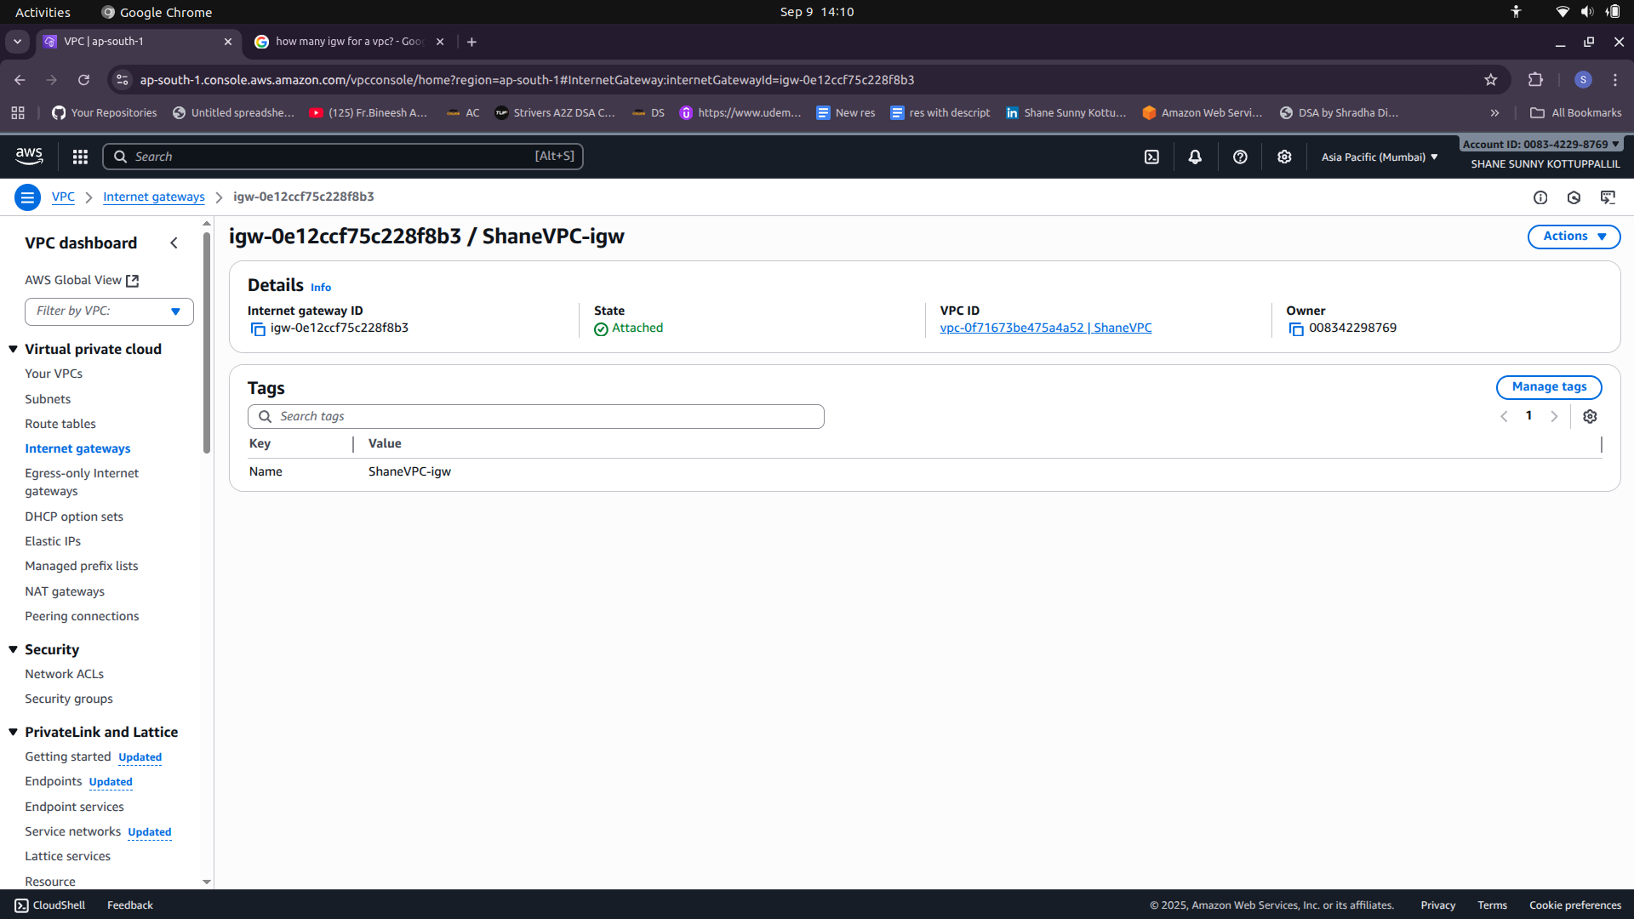

Route Tables

1) Route Table for Public Subnet

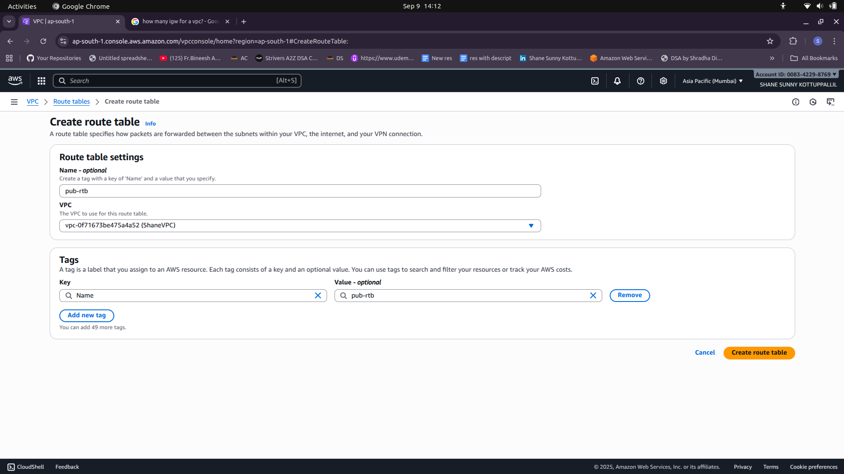

Public Subnet Associations and Edit Routes (To give IGW Route)

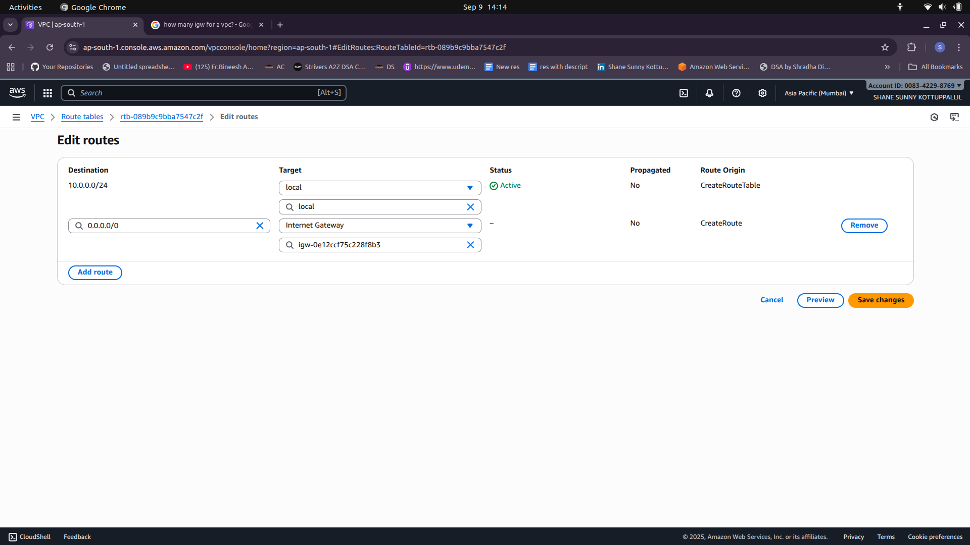

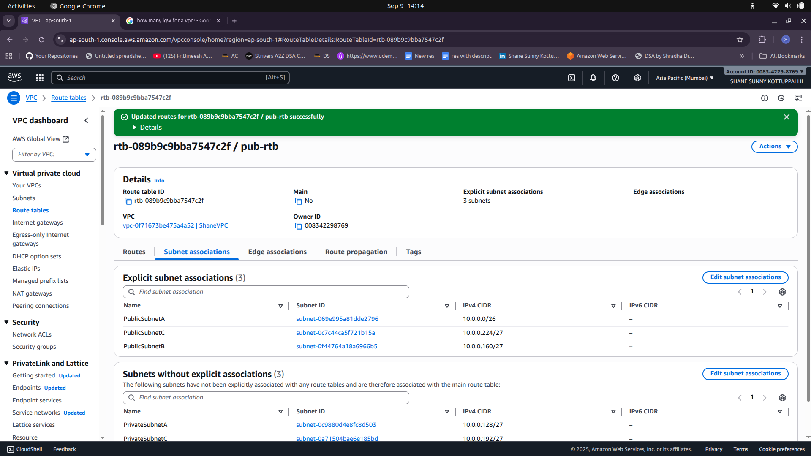

Bastion Hosts

1) Create Bastion Host (EC2 Instance) on Public Subnet with SSH access.

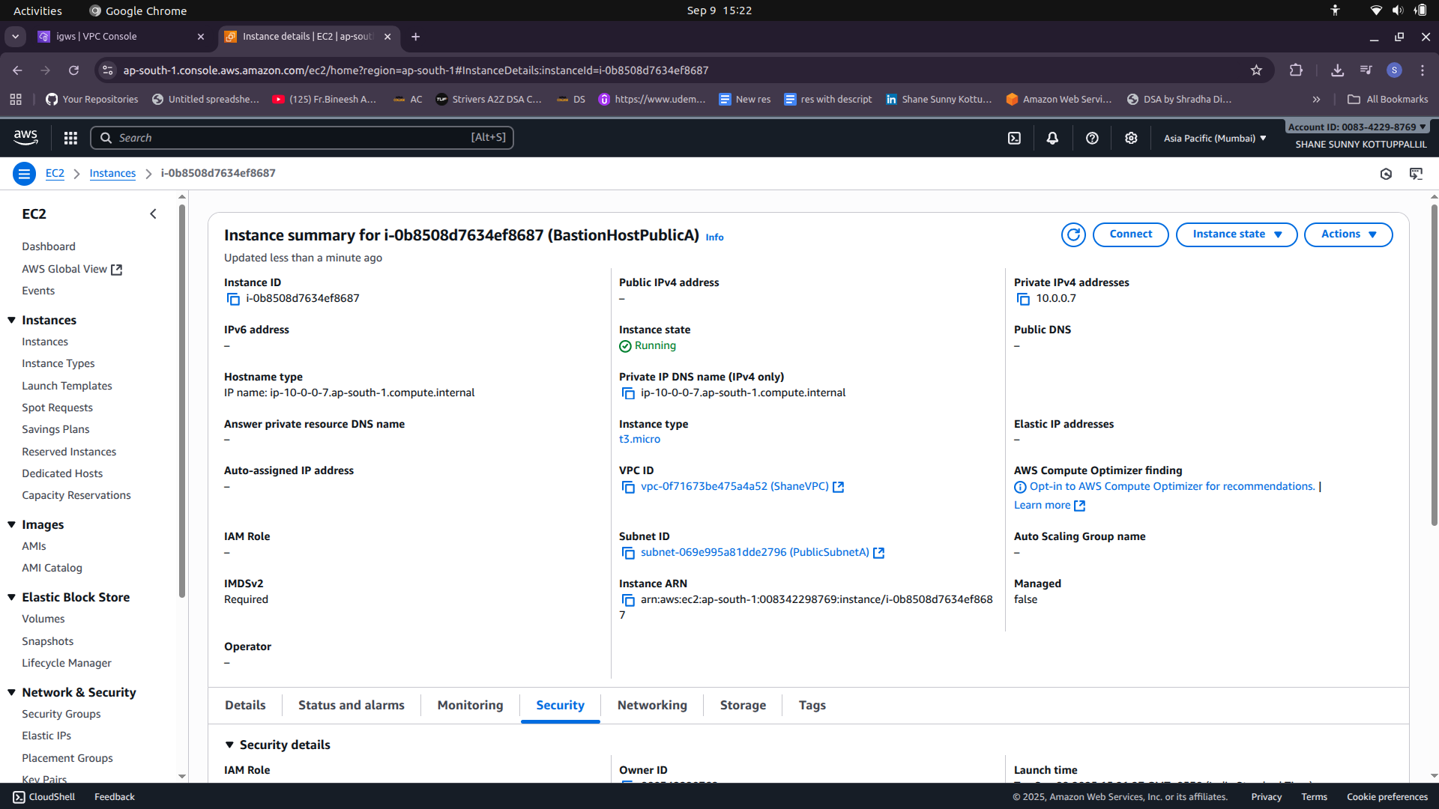
2)Create Private EC2 Instance on Private Subnet
-Allow SSH access only from Bastion Host’s Private IP.
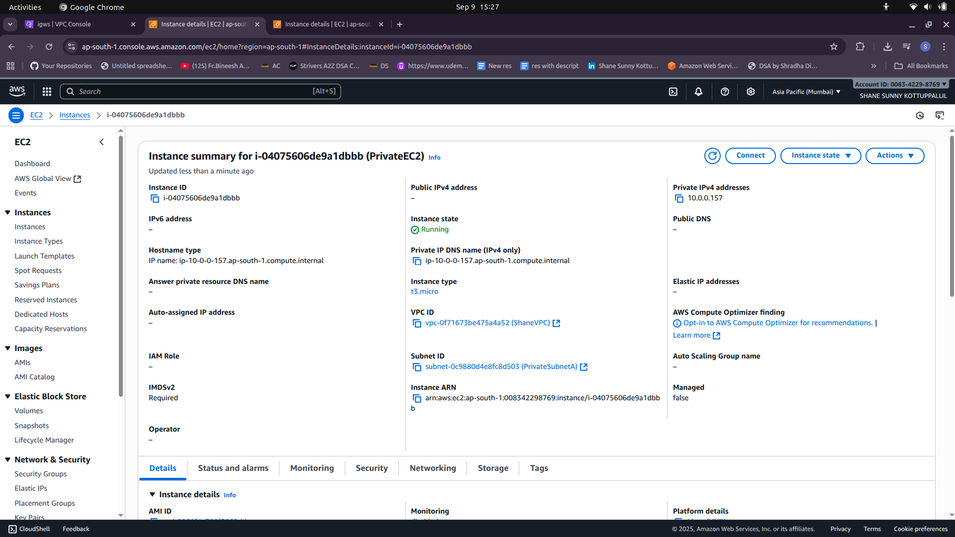
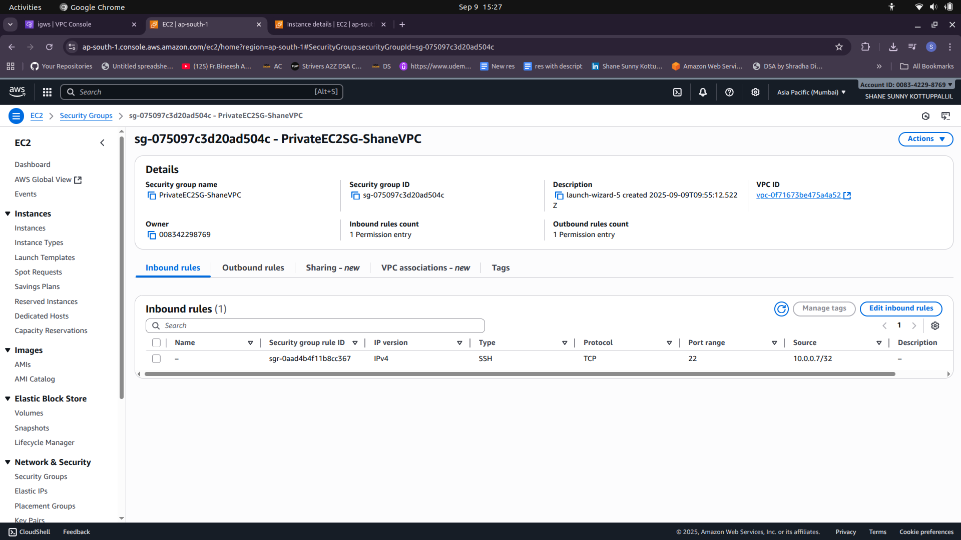

- Copy key pair on private instance and change permission of the pem file

vi Keypair.pem
chmod 400 Keypair.pem

ssh i Keypair.pem ec2user@privateIPBastion
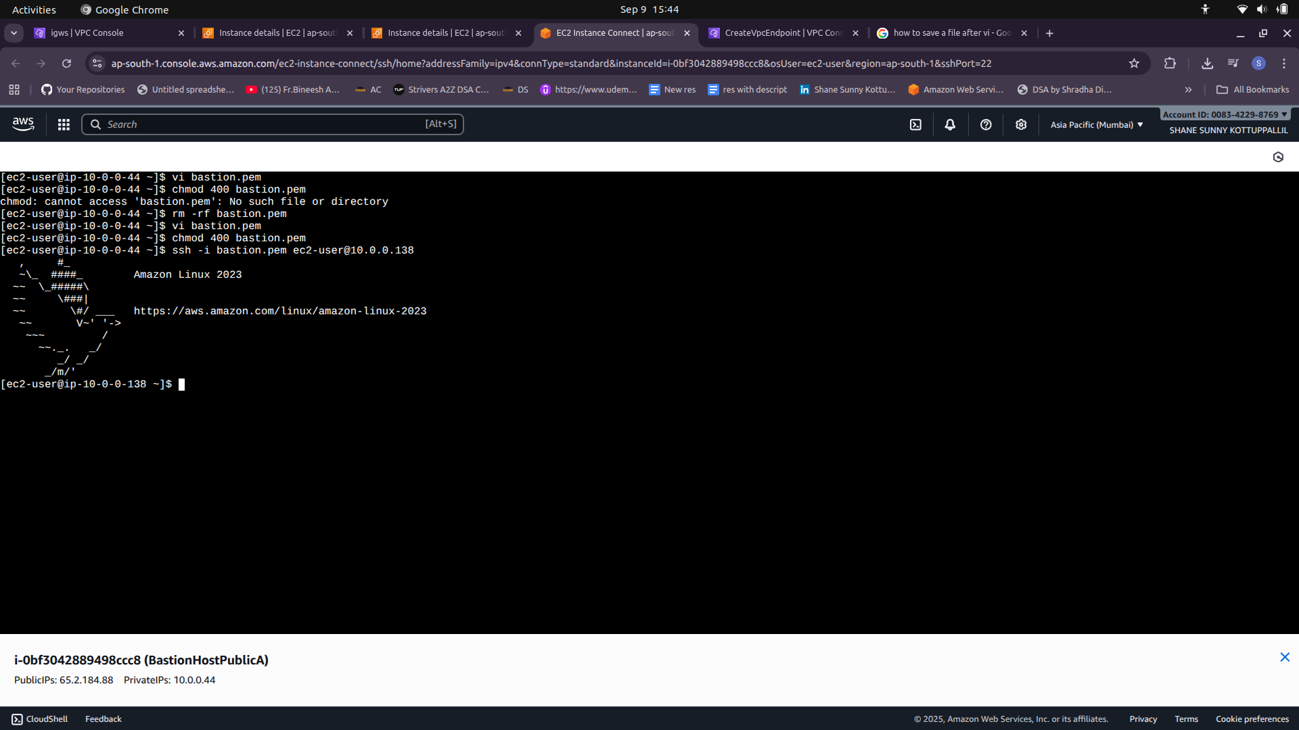
NAT Gateway

1) Create NAT Gateway and assign Elastic IP to it.
2) Router with Private subnet associations

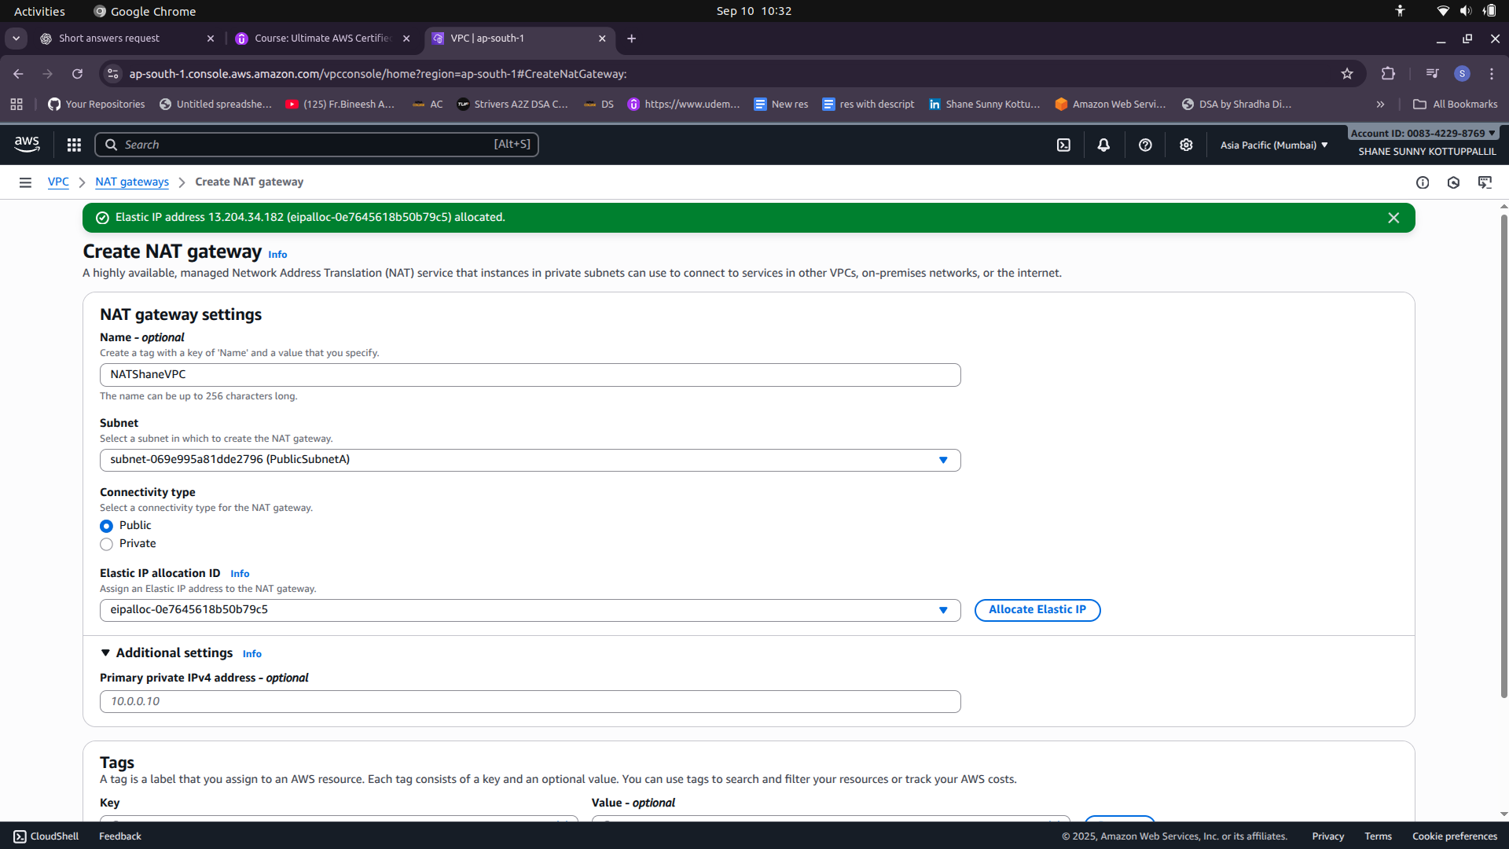

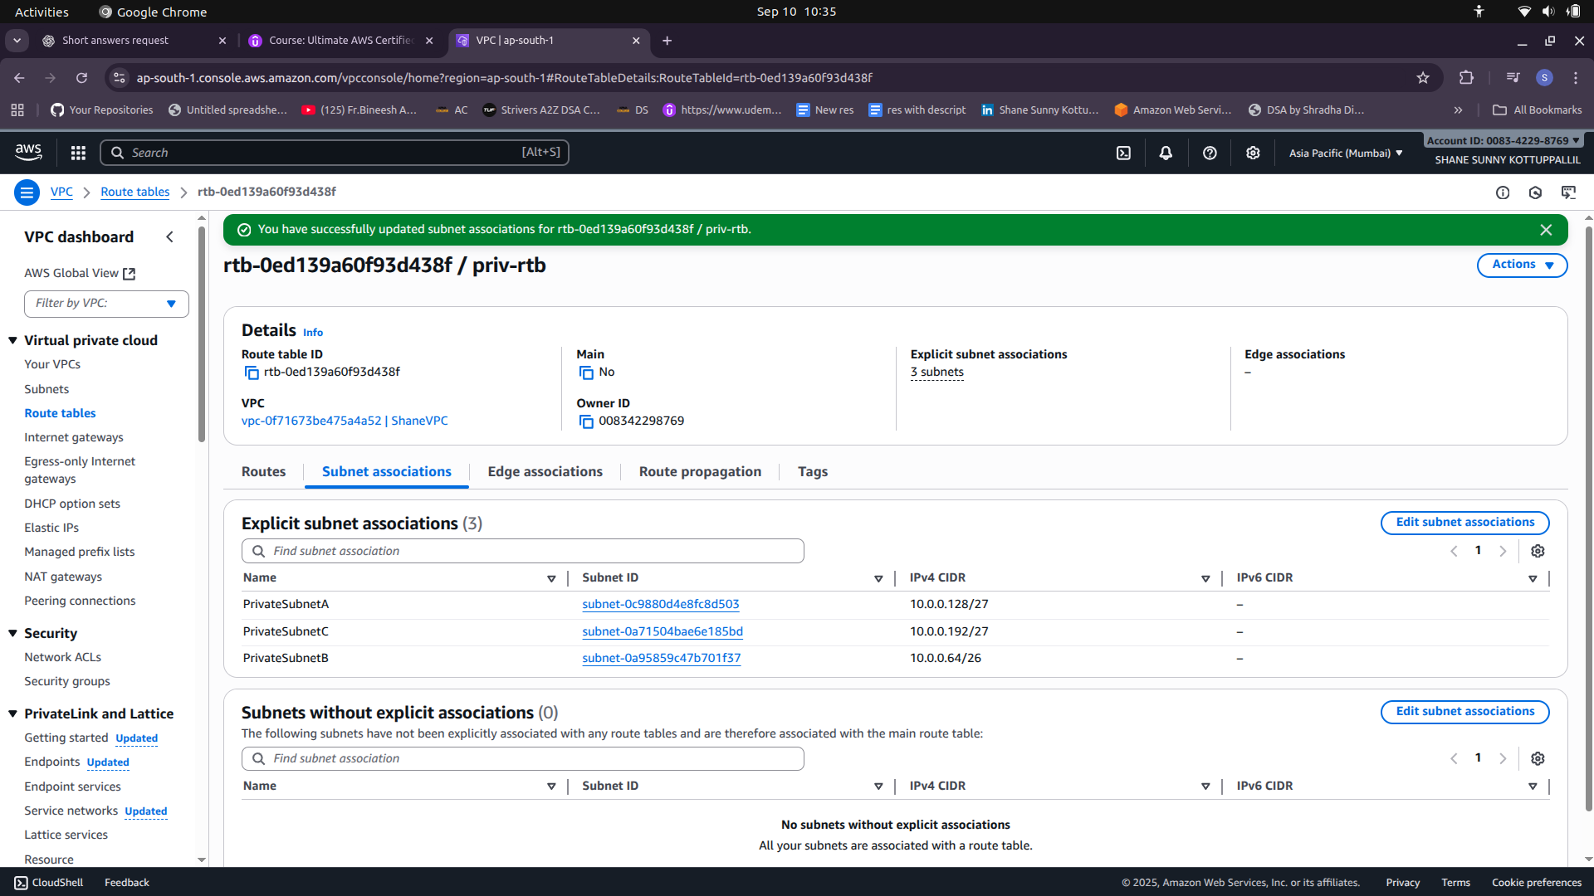

3) Create Route for NAT Gateway

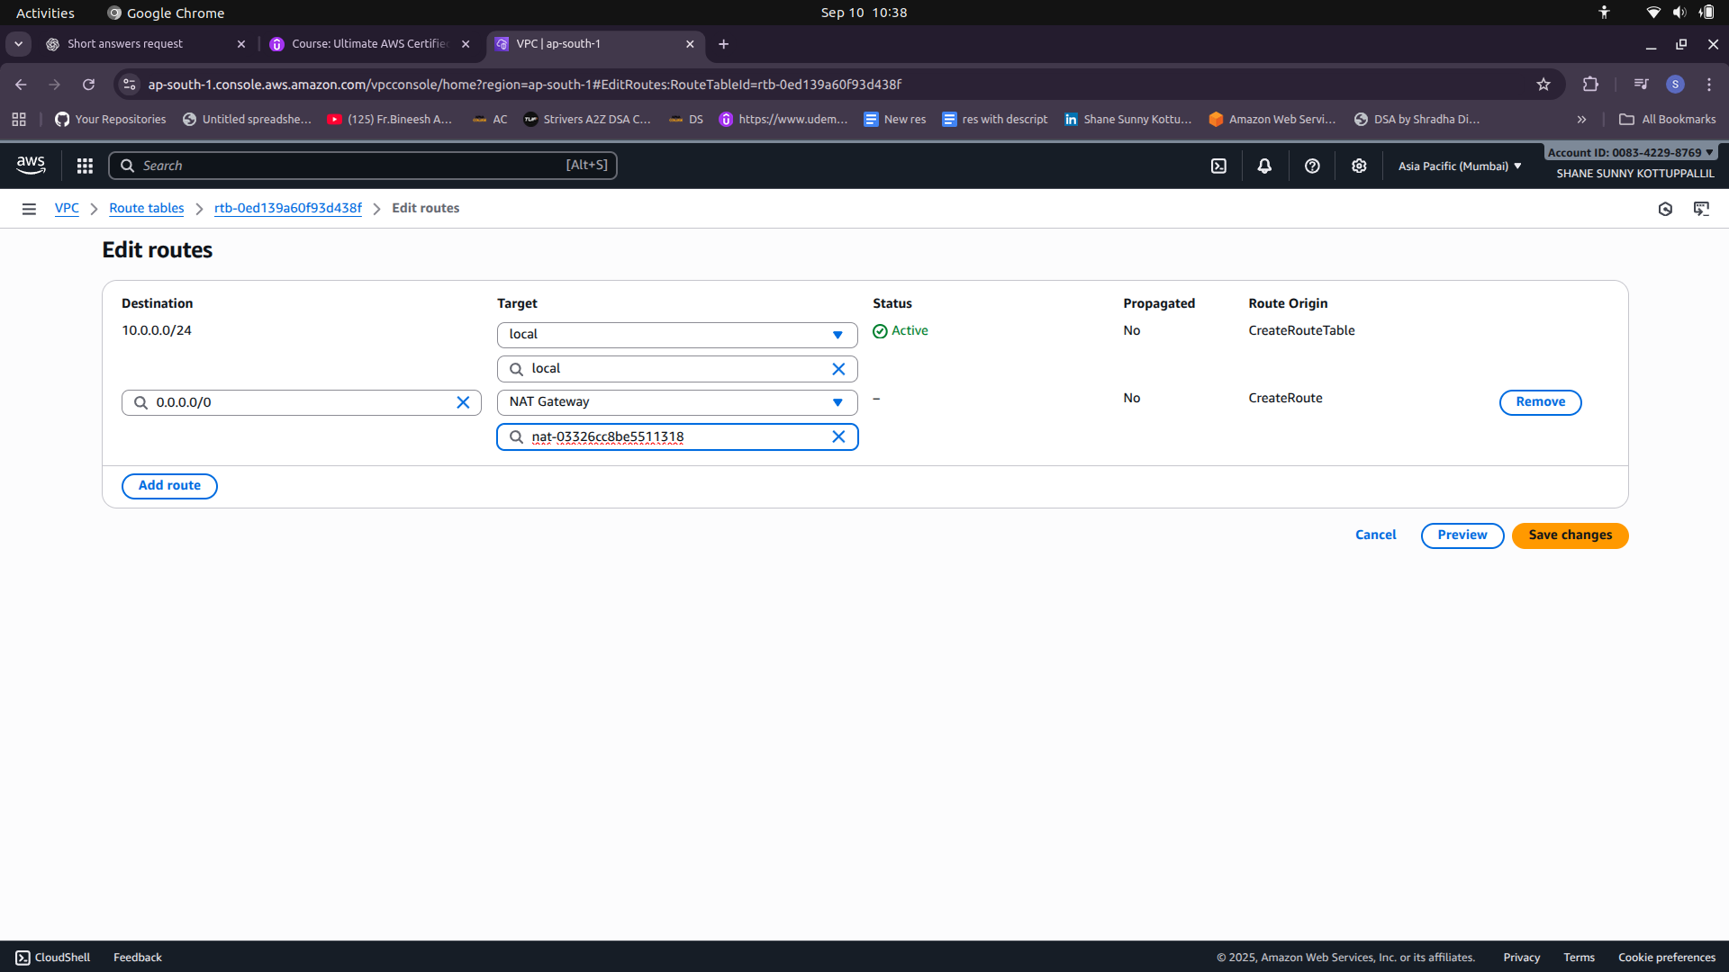
4) Verify if EC2 Instance in Private Subnet has Internet access.
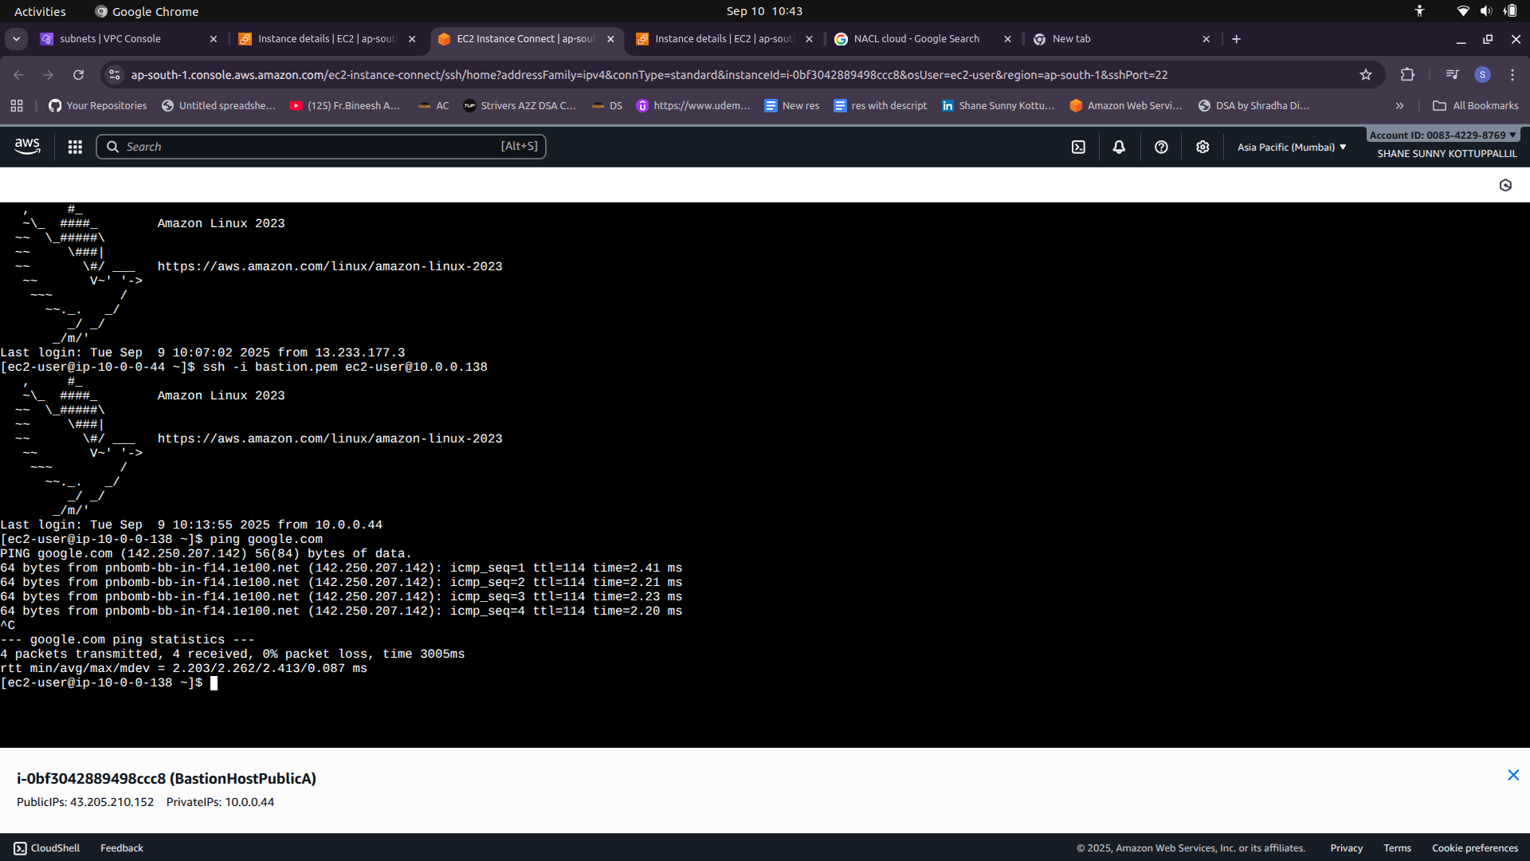

VPC Peering

1) Create VPC Peering (Peering Connections)

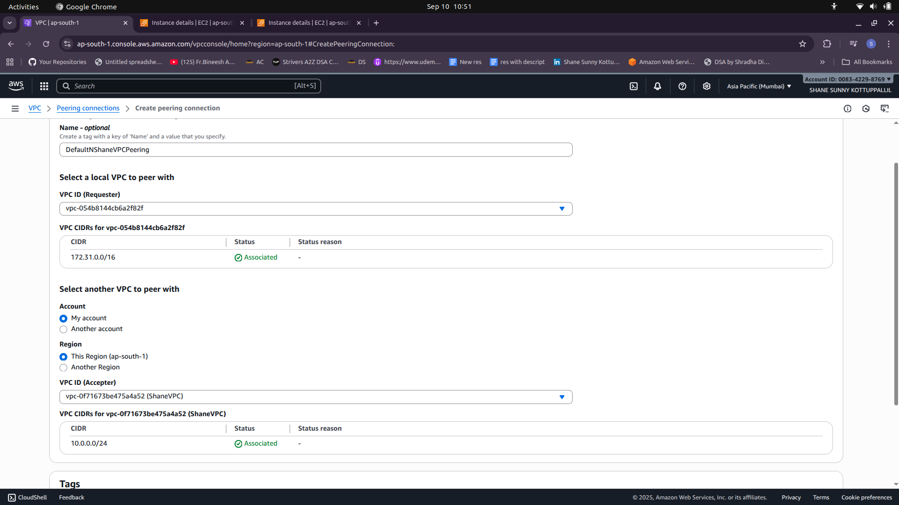
2) Accept Peering Connection Request

3) Edit Route Table

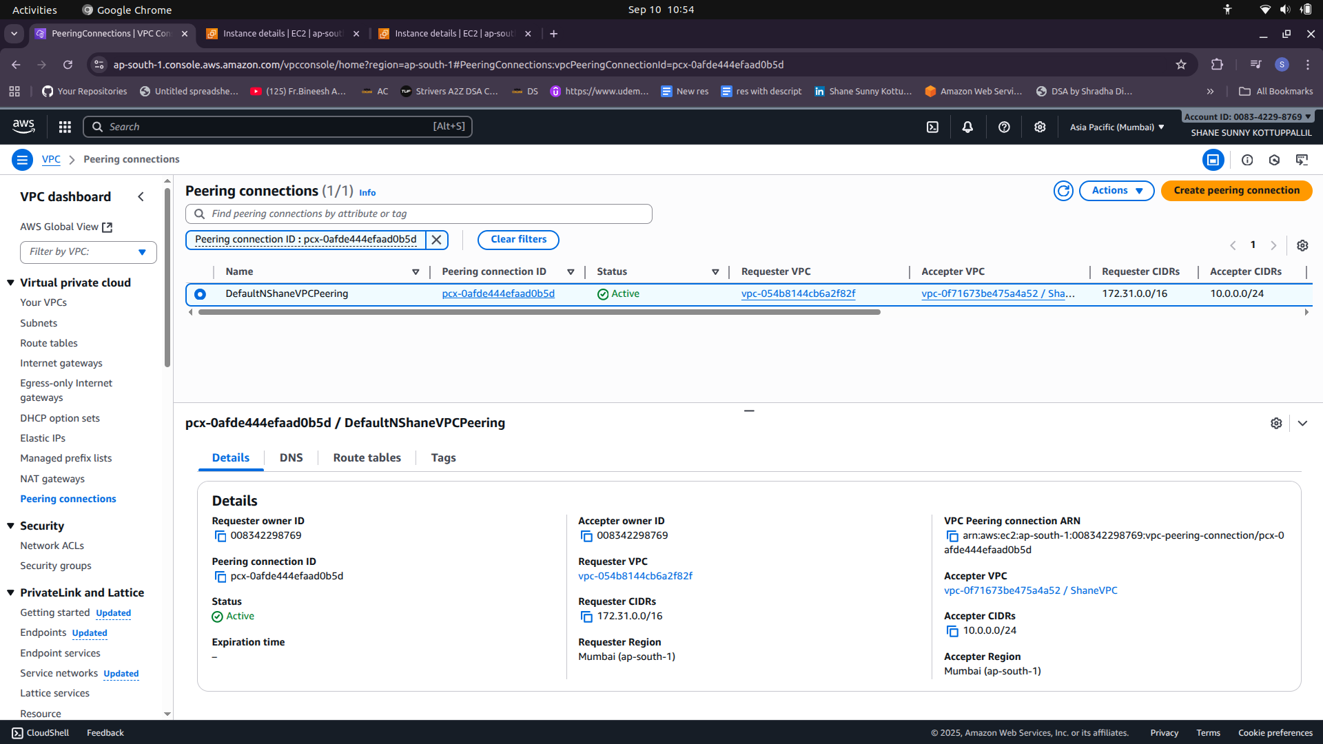
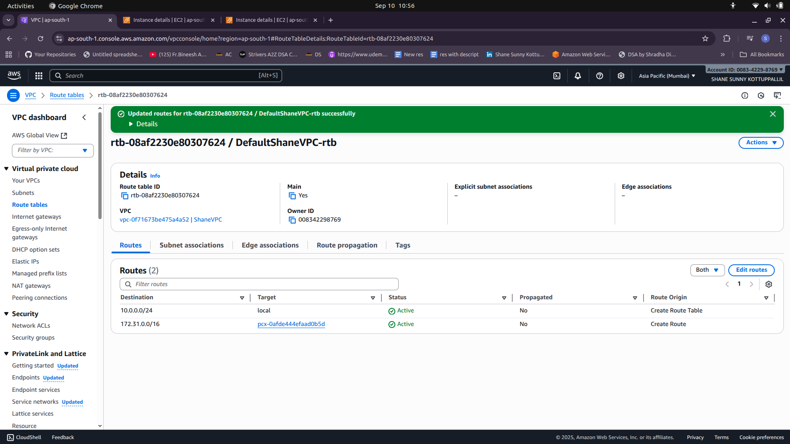

AWS CLI for Infrastructure

#!/usr/bin/env bash
# export AWS_REGION=ap-south-1
# export vpc_cidr="10.0.1.0/24"
# export vpc_name="ShaneVPC2"
# export ec2amiid="ami-02d26659fd82cf299"

set -euo pipefail
IFS=$'\n\t'

trap 'ret=$?; echo "ERROR: Script failed at line $LINENO with exit code $ret"; exit $ret' ERR

# Required env vars
: "${ec2amiid:?ERROR: please export ec2amiid (example: export ec2amiid=ami-0123456789abcdef0)}"

echo "Starting creation for VPC '${vpc_name}' with CIDR ${vpc_cidr}"
echo "Using AMI: $ec2amiid"
echo "AWS region: ${AWS_REGION:-(unset)}"
echo

# 1) Create VPC
echo "Creating VPC..."
vpc_create_out=$(aws ec2 create-vpc --cidr-block "$vpc_cidr" --tag-specifications "ResourceType=vpc,Tags=[{Key=Name,Value=$vpc_name}]" --region ap-south-1)
vpcid=$(echo "$vpc_create_out" | awk -F'"' '/VpcId/{print $4; exit}')
if [[ -z "$vpcid" ]]; then
echo "Failed to create VPC or fetch VpcId"
exit 1
fi
echo "Created VPC: $vpcid"

# 2) Create Subnets (public & private as per your plan)
echo "Creating subnets..."
# PublicSubnetA2 10.0.1.0/26 ap-south-1a
aws ec2 create-subnet --vpc-id "$vpcid" --cidr-block 10.0.1.0/26 --availability-zone ap-south-1a --tag-specifications 'ResourceType=subnet,Tags=[{Key=Name,Value=PublicSubnetA2}]' >/dev/null
# PublicSubnetB2 10.0.1.160/27 ap-south-1b
aws ec2 create-subnet --vpc-id "$vpcid" --cidr-block 10.0.1.160/27 --availability-zone ap-south-1b --tag-specifications 'ResourceType=subnet,Tags=[{Key=Name,Value=PublicSubnetB2}]' >/dev/null
# PublicSubnetC2 10.0.1.224/27 ap-south-1c
aws ec2 create-subnet --vpc-id "$vpcid" --cidr-block 10.0.1.224/27 --availability-zone ap-south-1c --tag-specifications 'ResourceType=subnet,Tags=[{Key=Name,Value=PublicSubnetC2}]' >/dev/null

# Private subnets
# PrivateSubnetB2 -10.0.1.64/26 -ap-south-1b
aws ec2 create-subnet --vpc-id "$vpcid" --cidr-block 10.0.1.64/26 --availability-zone ap-south-1b --tag-specifications 'ResourceType=subnet,Tags=[{Key=Name,Value=PrivateSubnetB2}]' >/dev/null
# PrivateSubnetA2 -10.0.1.128/27 -ap-south-1a
aws ec2 create-subnet --vpc-id "$vpcid" --cidr-block 10.0.1.128/27 --availability-zone ap-south-1a --tag-specifications 'ResourceType=subnet,Tags=[{Key=Name,Value=PrivateSubnetA2}]' >/dev/null
# PrivateSubnetC2 -10.0.1.192/27 -ap-south-1c
aws ec2 create-subnet --vpc-id "$vpcid" --cidr-block 10.0.1.192/27 --availability-zone ap-south-1c --tag-specifications 'ResourceType=subnet,Tags=[{Key=Name,Value=PrivateSubnetC2}]' >/dev/null

# Fetch subnet ids (first match of each name)
pubsubaid=$(aws ec2 describe-subnets --filters "Name=tag:Name,Values=PublicSubnetA2" "Name=vpc-id,Values=$vpcid" --query "Subnets[0].SubnetId" --output text)
pubsubbid=$(aws ec2 describe-subnets --filters "Name=tag:Name,Values=PublicSubnetB2" "Name=vpc-id,Values=$vpcid" --query "Subnets[0].SubnetId" --output text)
pubsubcid=$(aws ec2 describe-subnets --filters "Name=tag:Name,Values=PublicSubnetC2" "Name=vpc-id,Values=$vpcid" --query "Subnets[0].SubnetId" --output text)

prisubaid=$(aws ec2 describe-subnets --filters "Name=tag:Name,Values=PrivateSubnetA2" "Name=vpc-id,Values=$vpcid" --query "Subnets[0].SubnetId" --output text)
prisubbid=$(aws ec2 describe-subnets --filters "Name=tag:Name,Values=PrivateSubnetB2" "Name=vpc-id,Values=$vpcid" --query "Subnets[0].SubnetId" --output text)
prisubcid=$(aws ec2 describe-subnets --filters "Name=tag:Name,Values=PrivateSubnetC2" "Name=vpc-id,Values=$vpcid" --query "Subnets[0].SubnetId" --output text)

echo "Public subnets: $pubsubaid $pubsubbid $pubsubcid"
echo "Private subnets: $prisubaid $prisubbid $prisubcid"

# 3) Create and attach Internet Gateway
echo "Creating Internet Gateway..."
igwout=$(aws ec2 create-internet-gateway --tag-specifications 'ResourceType=internet-gateway,Tags=[{Key=Name,Value=ShaneVPC2igw}]')
igwid=$(echo "$igwout" | awk -F'"' '/InternetGatewayId/{print $4; exit}')
aws ec2 attach-internet-gateway --vpc-id "$vpcid" --internet-gateway-id "$igwid"
echo "Created & attached IGW: $igwid"

# 4) Allocate Elastic IP for NAT
echo "Allocating Elastic IP for NAT gateway..."
eipallocid=$(aws ec2 allocate-address --domain vpc --tag-specifications 'ResourceType=elastic-ip,Tags=[{Key=Name,Value=ShaneVPC2eip}]' --query 'AllocationId' --output text )
echo "Allocated EIP allocation-id: $eipallocid"

# 5) Create NAT Gateway in PublicSubnetA2 and wait until available
echo "Creating NAT Gateway in $pubsubaid..."
natout=$(aws ec2 create-nat-gateway --subnet-id "$pubsubaid" --allocation-id "$eipallocid" --tag-specifications 'ResourceType=natgateway,Tags=[{Key=Name,Value=ShaneVPC2natgw}]' )
natgwid=$(echo "$natout" | awk -F'"' '/NatGatewayId/{print $4; exit}')
echo "Created NAT gateway id: $natgwid"
echo "Waiting for NAT gateway to become available (this can take ~1-2 minutes)..."
aws ec2 wait nat-gateway-available --nat-gateway-ids "$natgwid"
echo "NAT gateway is available."

# 6) Create Public Route Table, add route to IGW, associate public subnets
echo "Creating public route table..."
pubrtout=$(aws ec2 create-route-table --vpc-id "$vpcid" --tag-specifications 'ResourceType=route-table,Tags=[{Key=Name,Value=pubrtbvpc2}]' )
pubrtbvpc2id=$(echo "$pubrtout" | awk -F'"' '/RouteTableId/{print $4; exit}')
echo "Public route table: $pubrtbvpc2id"
aws ec2 create-route --route-table-id "$pubrtbvpc2id" --destination-cidr-block 0.0.0.0/0 --gateway-id "$igwid"
aws ec2 associate-route-table --subnet-id "$pubsubaid" --route-table-id "$pubrtbvpc2id"
aws ec2 associate-route-table --subnet-id "$pubsubbid" --route-table-id "$pubrtbvpc2id"
aws ec2 associate-route-table --subnet-id "$pubsubcid" --route-table-id "$pubrtbvpc2id"
echo "Associated public subnets to public route table."

# 7) Create Private Route Table, add route to NAT, associate private subnets
echo "Creating private route table..."
privrtout=$(aws ec2 create-route-table --vpc-id "$vpcid" --tag-specifications 'ResourceType=route-table,Tags=[{Key=Name,Value=prirtbvpc2}]' )
prirtbvpc2id=$(echo "$privrtout" | awk -F'"' '/RouteTableId/{print $4; exit}')
echo "Private route table: $prirtbvpc2id"
aws ec2 create-route --route-table-id "$prirtbvpc2id" --destination-cidr-block 0.0.0.0/0 --nat-gateway-id "$natgwid"
aws ec2 associate-route-table --subnet-id "$prisubaid" --route-table-id "$prirtbvpc2id"
aws ec2 associate-route-table --subnet-id "$prisubbid" --route-table-id "$prirtbvpc2id"
aws ec2 associate-route-table --subnet-id "$prisubcid" --route-table-id "$prirtbvpc2id"
echo "Associated private subnets to private route table."

# 8) Create Security Groups (fail-fast if any command errors)
echo "Creating security groups..."
albwebsgcliid=$(aws ec2 create-security-group --group-name alb-web-sg-cli --vpc-id "$vpcid" --description "Security Group for Internet Facing ALB" --tag-specifications 'ResourceType=security-group,Tags=[{Key=Name,Value=alb-web-sg-cli}]' --query 'GroupId' --output text)
chatwebsgcliid=$(aws ec2 create-security-group --group-name chat-web-sg-cli --vpc-id "$vpcid" --description "Security Group for Web EC2 / Web ASG" --tag-specifications 'ResourceType=security-group,Tags=[{Key=Name,Value=chat-web-sg-cli}]' --query 'GroupId' --output text)
albappsgcliid=$(aws ec2 create-security-group --group-name alb-app-sg-cli --vpc-id "$vpcid" --description "Security Group for Internal ALB" --tag-specifications 'ResourceType=security-group,Tags=[{Key=Name,Value=alb-app-sg-cli}]' --query 'GroupId' --output text)
chatappsgcliid=$(aws ec2 create-security-group --group-name chat-app-sg-cli --vpc-id "$vpcid" --description "Security Group for App EC2 / App ASG" --tag-specifications 'ResourceType=security-group,Tags=[{Key=Name,Value=chat-app-sg-cli}]' --query 'GroupId' --output text)
dbsgcliid=$(aws ec2 create-security-group --group-name db-sg-cli --vpc-id "$vpcid" --description "Security Group for MySQL DB" \
--tag-specifications 'ResourceType=security-group,Tags=[{Key=Name,Value=db-sg-cli}]' --query 'GroupId' --output text)
chatbastsgcliid=$(aws ec2 create-security-group --group-name chat-bast-sg-cli --vpc-id "$vpcid" --description "SG for Bastion Host" \
--tag-specifications 'ResourceType=security-group,Tags=[{Key=Name,Value=chat-bast-sg-cli}]' --query 'GroupId' --output text)

echo "SG IDs:"
echo " alb-web-sg-cli: $albwebsgcliid"
echo " chat-web-sg-cli: $chatwebsgcliid"
echo " alb-app-sg-cli: $albappsgcliid"
echo " chat-app-sg-cli: $chatappsgcliid"
echo " db-sg-cli: $dbsgcliid"
echo " chat-bast-sg-cli: $chatbastsgcliid"

# 9) Authorize SG rules (strict; will error and exit on any invalid parameter)
echo "Authorizing security group rules..."

# alb-web-sg-cli: Inbound 80 from 0.0.0.0/0
aws ec2 authorize-security-group-ingress --group-id "$albwebsgcliid" --protocol tcp --port 80 --cidr 0.0.0.0/0
# alb-web-sg-cli: Outbound 80 to chat-web-sg-cli
aws ec2 authorize-security-group-egress --group-id "$albwebsgcliid" --ip-permissions "[{\"IpProtocol\":\"tcp\",\"FromPort\":80,\"ToPort\":80,\"UserIdGroupPairs\":[{\"GroupId\":\"$chatwebsgcliid\"}]}]"

# chat-web-sg-cli: Inbound 80 from alb-web-sg-cli
aws ec2 authorize-security-group-ingress --group-id "$chatwebsgcliid" --ip-permissions "[{\"IpProtocol\":\"tcp\",\"FromPort\":80,\"ToPort\":80,\"UserIdGroupPairs\":[{\"GroupId\":\"$albwebsgcliid\"}]}]"

# chat-web-sg-cli: Outbound 80 to alb-app-sg-cli
aws ec2 authorize-security-group-egress --group-id "$chatwebsgcliid" --ip-permissions "[{\"IpProtocol\":\"tcp\",\"FromPort\":80,\"ToPort\":80,\"UserIdGroupPairs\":[{\"GroupId\":\"$albappsgcliid\"}]}]"
aws ec2 authorize-security-group-ingress --group-id "$albappsgcliid" --ip-permissions "[{\"IpProtocol\":\"tcp\",\"FromPort\":80,\"ToPort\":80,\"UserIdGroupPairs\":[{\"GroupId\":\"$chatwebsgcliid\"}]}]"

# alb-app-sg-cli: Outbound 8001 to chat-app-sg-cli
aws ec2 authorize-security-group-egress --group-id "$albappsgcliid" --ip-permissions "[{\"IpProtocol\":\"tcp\",\"FromPort\":8001,\"ToPort\":8001,\"UserIdGroupPairs\":[{\"GroupId\":\"$chatappsgcliid\"}]}]"

# chat-app-sg-cli: Inbound 8001 from alb-app-sg-cli
aws ec2 authorize-security-group-ingress --group-id "$chatappsgcliid" --ip-permissions "[{\"IpProtocol\":\"tcp\",\"FromPort\":8001,\"ToPort\":8001,\"UserIdGroupPairs\":[{\"GroupId\":\"$albappsgcliid\"}]}]"

# chat-app-sg-cli: Outbound 3306 to db-sg-cli
aws ec2 authorize-security-group-egress --group-id "$chatappsgcliid" --ip-permissions "[{\"IpProtocol\":\"tcp\",\"FromPort\":3306,\"ToPort\":3306,\"UserIdGroupPairs\":[{\"GroupId\":\"$dbsgcliid\"}]}]"

# db-sg-cli: Inbound 3306 from chat-app-sg-cli
aws ec2 authorize-security-group-ingress --group-id "$dbsgcliid" --ip-permissions "[{\"IpProtocol\":\"tcp\",\"FromPort\":3306,\"ToPort\":3306,\"UserIdGroupPairs\":[{\"GroupId\":\"$chatappsgcliid\"}]}]"

aws ec2 authorize-security-group-ingress \
--group-id "$chatbastsgcliid" \
--ip-permissions '[{"IpProtocol":"tcp","FromPort":22,"ToPort":22,"IpRanges":[{"CidrIp":"0.0.0.0/0","Description":"SSH Access to BastionHost"}]}]'

# 2) Bastion egress: allow bastion to initiate SSH to the three tiers (tightest option)
aws ec2 authorize-security-group-egress \
--group-id "$chatbastsgcliid" \
--ip-permissions '[{"IpProtocol":"tcp","FromPort":22,"ToPort":22,"UserIdGroupPairs":[{"GroupId":"'"$chatwebsgcliid"'","Description":"to-web-sg"},{"GroupId":"'"$chatappsgcliid"'","Description":"to-app-sg"},{"GroupId":"'"$chatdbsgcliid"'","Description":"to-db-sg"}]}]'

# 3) Target SGs: allow SSH inbound FROM the bastion SG
aws ec2 authorize-security-group-ingress \
--group-id "$chatwebsgcliid" \
--ip-permissions '[{"IpProtocol":"tcp","FromPort":22,"ToPort":22,"UserIdGroupPairs":[{"GroupId":"'"$chatbastsgcliid"'"}]}]'

aws ec2 authorize-security-group-ingress \
--group-id "$chatappsgcliid" \
--ip-permissions '[{"IpProtocol":"tcp","FromPort":22,"ToPort":22,"UserIdGroupPairs":[{"GroupId":"'"$chatbastsgcliid"'"}]}]'

aws ec2 authorize-security-group-ingress \
--group-id "$chatdbsgcliid" \
--ip-permissions '[{"IpProtocol":"tcp","FromPort":22,"ToPort":22,"UserIdGroupPairs":[{"GroupId":"'"$chatbastsgcliid"'"}]}]'
# --- end SSH / Bastion rules ---

echo "Security group rules applied."

# 10) Create EC2 instances (examples) — ensure key pair 'chatapp' exists in your account and region
echo "Launching EC2 instances..."

# ChatDBA2 in private subnet (no public IP)
aws ec2 run-instances --image-id "$ec2amiid" --instance-type t3.micro --key-name "chatapp" --subnet-id "$prisubaid" --security-group-ids "$dbsgcliid" --count 1 --tag-specifications 'ResourceType=instance,Tags=[{Key=Name,Value=ChatDBA2}]'

# ChatAppA2 in public subnet (example)
aws ec2 run-instances --image-id "$ec2amiid" --instance-type t3.micro --key-name "chatapp" --subnet-id "$pubsubaid" --security-group-ids "$chatappsgcliid" --count 1 --tag-specifications 'ResourceType=instance,Tags=[{Key=Name,Value=ChatAppA2}]'

# ChatWebA2 in public subnet
aws ec2 run-instances --image-id "$ec2amiid" --instance-type t3.micro --key-name "chatapp" --subnet-id "$pubsubaid" --security-group-ids "$chatwebsgcliid" --count 1 --tag-specifications 'ResourceType=instance,Tags=[{Key=Name,Value=ChatWebA2}]'

# BastionHostA2 in public subnet (associate public ip)
aws ec2 run-instances --image-id "$ec2amiid" --instance-type t3.micro --key-name "chatapp" --subnet-id "$pubsubaid" --security-group-ids "$chatbastsgcliid" --count 1 \
--tag-specifications 'ResourceType=instance,Tags=[{Key=Name,Value=BastionHostA2}]' --associate-public-ip-address

echo "EC2 instances launched."

echo
echo "All resources created successfully."
echo "VPC: $vpcid"
echo "Subnets (public): $pubsubaid $pubsubbid $pubsubcid"
echo "Subnets (private): $prisubaid $prisubbid $prisubcid"
echo "IGW: $igwid NATGW: $natgwid EIP allocation: $eipallocid"
echo "RouteTables: public=$pubrtbvpc2id private=$prirtbvpc2id"
echo "Security Groups: alb-web=$albwebsgcliid chat-web=$chatwebsgcliid alb-app=$albappsgcliid chat-app=$chatappsgcliid db=$dbsgcliid"

